ASSIGNMENT -4

1).

RAM Size:

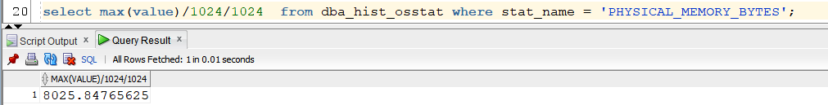

Location of the files:

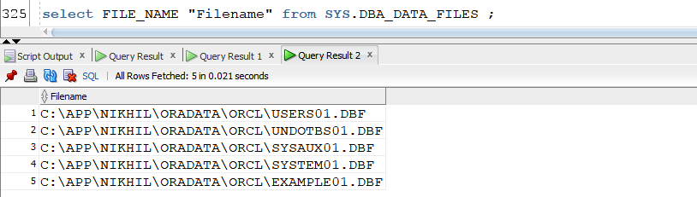

Memory Size:

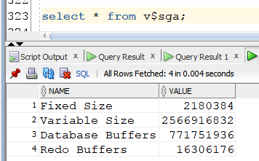

Database Size:

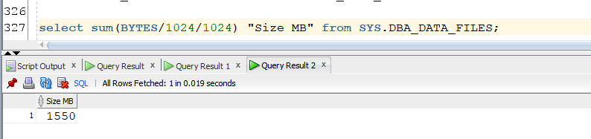

Version of Database:

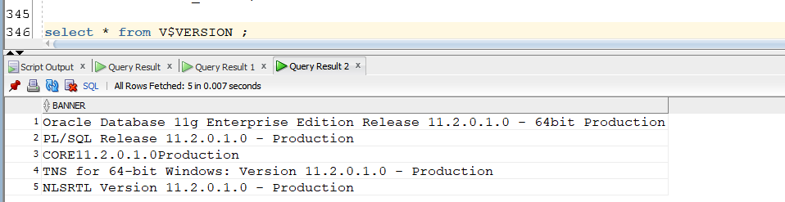

2).

* STOCK_B

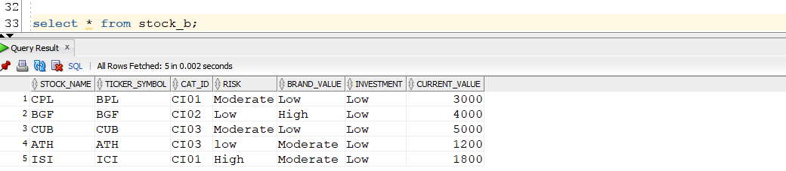

* STOCK_A

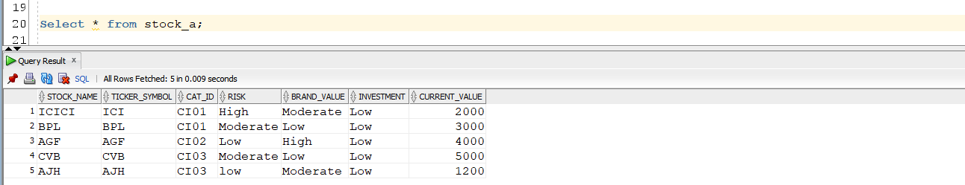

* MERGE UPSERT QUERY

merge into stock_a a

using

(select ticker_symbol, Stock_name, cat_id, risk , brand_value,investment, current_value

from stock_b) b

on (a.ticker_symbol = b.ticker_symbol)

when matched then

update set a.Stock_name = b.Stock_name

, a.current_value = b.current_value

delete where a.current_value < 2500

when not matched then

insert ( a.Stock_name,a.ticker_symbol, a.cat_id, a.risk, a.brand_value, a.investment, a.current_value)

values ( b.Stock_name,b.ticker_symbol, b.cat_id, b.risk, b.brand_value, b.investment, b.current_value);

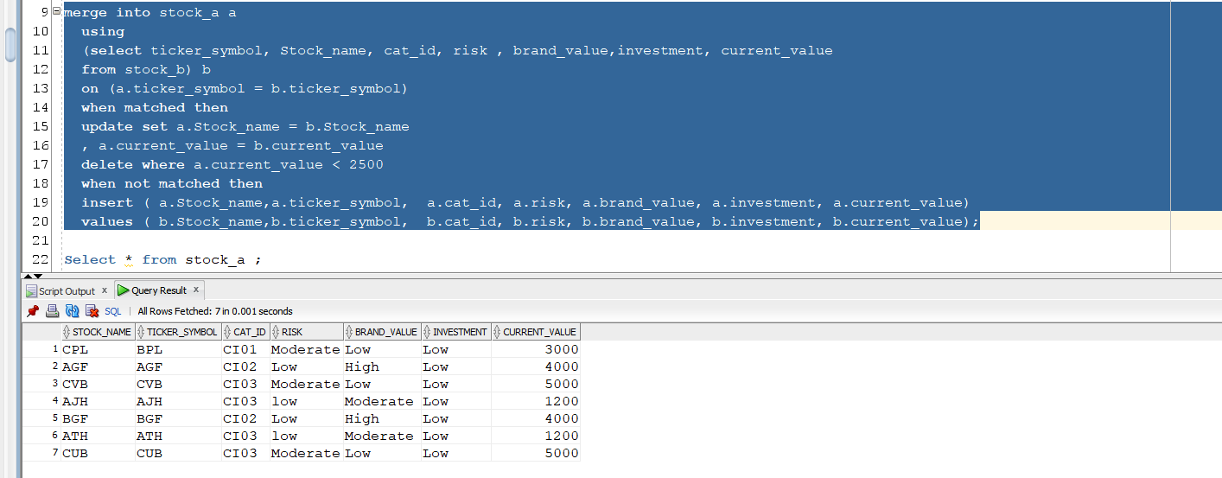

* So the Upsert query has helped to update 2 rows with ticker_symbol = (‘ICI’ and ‘BPL’) and changed its STOCK_NAME and CURRENT_VALUE. But since the matched rows with ticker_symbol = (‘ICI’) had CURRENT_VALUE = 1800 it got deleted after getting updated because of the delete condition in the UPSERT query which was current_value less than 2500. And all the other three rows which did not match the UPSERT condition they got inserted from stock_b table into stock_a table.
* Below attached is the script output for the UPSERT QUERY:

